6/16/2019 LHSS

Kalbis Institute

 |  |  |  |  |  |  |  |  |  |  |  |  |  |  | ** Semester Study Report |  |  |  |  |  |  |  |  |  | **
 |  |  |  |  |  |  |  |  |  |  |  |  |  | ___________________________
 |  |  |  |  |  |  |  |  |  |  |  |  | Semester: Odd Academic Year: 2017 - 2018
 | Study Program |  |  | : Informatika |  |  |  |  |  |  |  |  |  |  |  |  |  |  |  |  |  |  |  |  |  |  |  | Student Registration Number : 2017103636
 | Stream |  |  | : Soft Computing |  |  |  |  |  |  |  |  |  |  |  |  |  |  |  |  |  |  |  |  |  |  |  | Student Name |  |  |  |  |  |  |  |  | : Ying Chen
 | Program Degree : Undergraduate Program
 |  |  |  |  |  |  |  |  |  | Attendance |  |  |  |  |  |  |  |  |  |  |  |  |  |  |  |  |  |  |  |  | Score
 | Courses |  |  | Class |  |  | ^{CCU} Theory Practicum |  |  |  |  |  |  |  |  |  |  |  |  |  | Theory |  |  |  |  |  |  |  |  |  |  |  |  | Practicum |  |  |  |  |  |  |  |  | Result Grade Credit
 |  |  |  |  |  |  |  |  |  |  |  |  |  | 1 |  |  |  | 2 | 3 |  |  | 4 |  |  | 5 |  | 6 |  | 1 |  | 2 |  | 3 |  | 4 |  |  | 5 |  | 6
 | IW0003 -
 | Kalbispreneur 01PBIF 3/0 |  |  |  |  |  |  | 13/13 |  |  | -/- |  |  | 73.33 |  |  |  | 85.00 | 100.00 |  |  | 74.00 |  |  | 95.00 |  |  | N/A |  | N/A |  | N/A |  | N/A |  |  | N/A |  | N/A |  | N/A | 87 |  |  | A | 12
 | I
 | TI0084 -
 | Programming 01PBIF |  |  |  | 3/1 |  |  | 13/13 |  |  | 13/13 |  |  | 80.00 |  |  |  | 80.00 | 85.00 |  |  | 85.00 |  |  | 80.00 76.00 80.00 85.00 93.00 85.00 80.00 80.00 |  |  |  |  |  |  |  |  |  |  |  |  |  |  |  |  | 81 |  |  | A | 16
 | and Algorithm
 | TI2122 -
 | Technology
 | and |  |  | 01PBIF 2/0 |  |  |  | 13/13 |  |  | -/- |  |  | 85.00 |  |  |  | 85.00 | 85.00 |  |  | 86.00 |  |  | 88.00 |  |  | N/A |  | N/A |  | N/A |  | N/A |  |  | N/A |  | N/A |  | N/A | 86 |  |  | A | 8
 | Profession in |  |  |  |  |  |  |  |  |  |  |  |  |  |  |  |  |  |  |  |  |  |  |  |  |  |  | N/A |  | N/A |  | N/A |  | N/A |  |  | N/A |  | N/A |  | N/A |  |  |  | A
 | Computer
 | Field
 | TI3073 - Basic
 | Web |  |  | 01PBIF | 2/1 |  |  | 13/13 |  |  | 13/13 |  |  | 88.33 |  |  |  | 100.00 | 88.33 |  |  | 95.00 |  |  |  | N/A |  | N/A | 88.33 80.00 88.33 90.00 |  |  |  |  |  |  |  |  |  | N/A |  | N/A | 91 |  |  | A | 12
 | Programming
 | UM1082 - |  |  | 01PBIF 2/0 |  |  |  | 11/13 |  |  | -/- |  |  | 75.00 |  |  |  | 76.00 | 90.00 |  |  | 75.00 |  |  | 76.00 80.00 |  |  |  |  | N/A |  | N/A |  | N/A |  |  | N/A |  | N/A |  | N/A | 80 |  |  | A | 8
 | Religion |  |  |  |  |  |  |  |  |  |  |  |  |  |  |  |  |  |  |  |  |  |  |  |  |  |  |  |  | N/A |  | N/A |  | N/A |  |  | N/A |  | N/A |  | N/A |  |  |  | A
 | UM2123 -
 | Applied
 | Mathematics |  |  | 01PBIF | 2/1 |  |  | 13/13 |  |  | 13/13 |  |  | 100.00 |  |  |  | 80.00 | 90.00 |  |  | 90.00 |  |  | 88.00 |  |  | N/A | 90.00 95.00 90.00 80.00 |  |  |  |  |  |  |  |  |  | N/A |  | N/A | 88 |  |  | A | 12
 | on Computer
 | Science I
 | UM3053 -
 | Science and |  |  | 01PBIF 3/0 |  |  |  | 13/13 |  |  | -/- |  |  | 89.00 |  |  |  | 90.00 | 89.00 |  |  | 100.00 87.00 95.00 |  |  |  |  |  |  |  | N/A |  | N/A |  | N/A |  |  | N/A |  | N/A |  | N/A | 93 |  |  | A | 12
 | Critical
 | Thinking
 | ** Total ** |  |  |  | 20 |  |  |  |  |  |  |  |  |  |  |  |  |  |  |  |  |  |  |  |  |  |  |  |  |  |  |  |  |  |  |  |  |  |  |  |  |  |  |  |  | 80
 | Semester Grade Point Average / Semester Credit Units |  |  |  |  |  |  |  |  |  |  |  |  |  |  |  | : 4.00/20
 | Cumulative Grade Point Average / Cumulative Credit Units : 4.00/17
 | End of Study Valid Period |  |  |  |  |  |  |  |  |  |  |  |  |  |  |  |  | : Odd/Even Semester 2024


**********************************************
gratulations, we're proud of your achievements
**************************************** *

Course Grade:
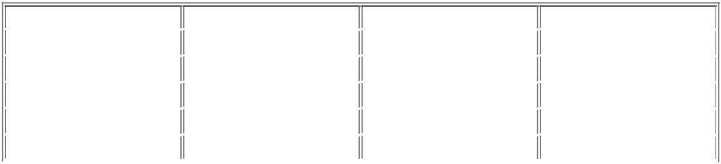

 | Quality Letter |  | Range of Final Grade |  | Quality Number |  | Quality Predicate
 | A |  | 80 ≤ x ≤ 100 | 4 |  |  | Excellent
 | B |  | 66 ≤ x ≤ 80 | 3 |  |  | Good
 | C |  | 55 ≤ x ≤ 66 | 2 |  |  | Satisfactory
 | D |  | 45 ≤ x ≤ 55 | 1 |  |  | Unsatisfactory
 | E | < 45 |  | 0 |  |  | Failed

This document is processed by the computer and is valid without Kalbis Institute Official Signature / Stamp.

kalbisphere.kalbis.ac.id/Kalbisphere/module/studentS1/score/do/doPrint.jsp?ID_Period=20 1/1

